Azure DevOps free service offering

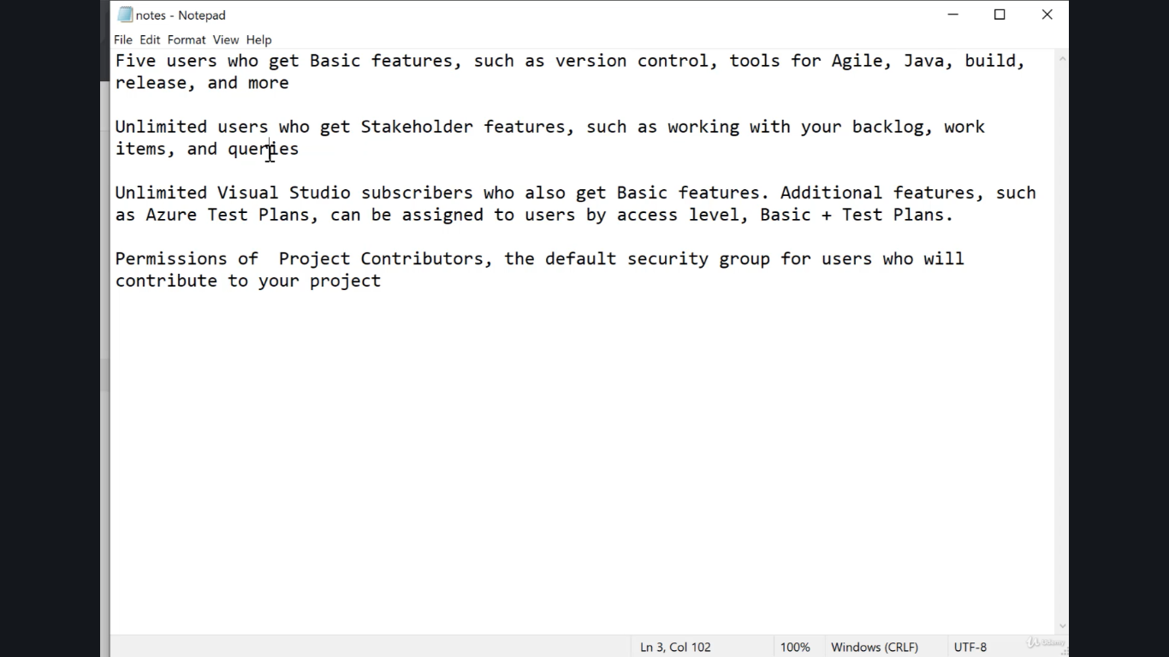

Charts

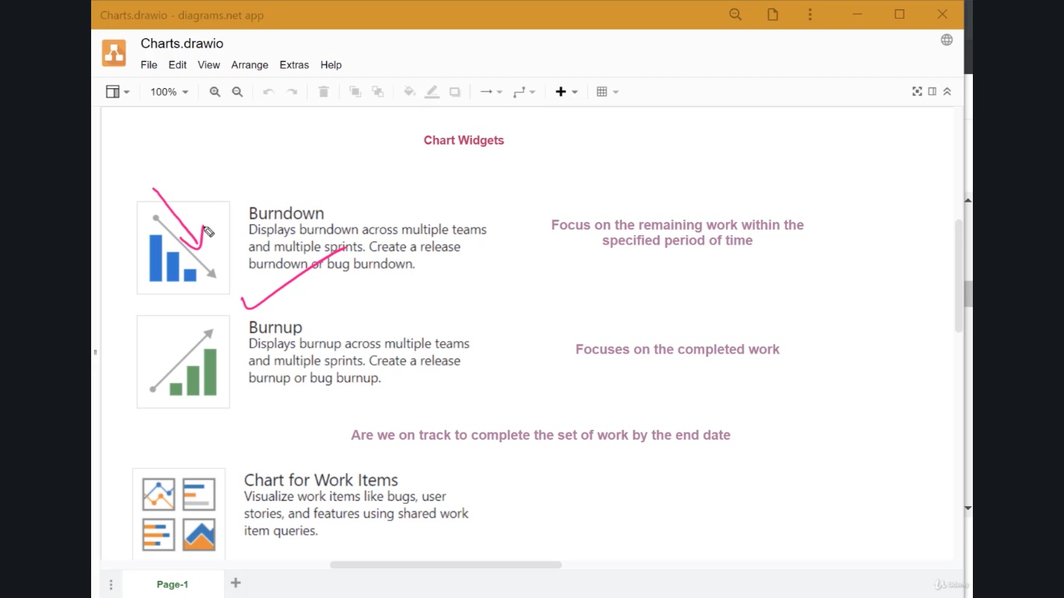

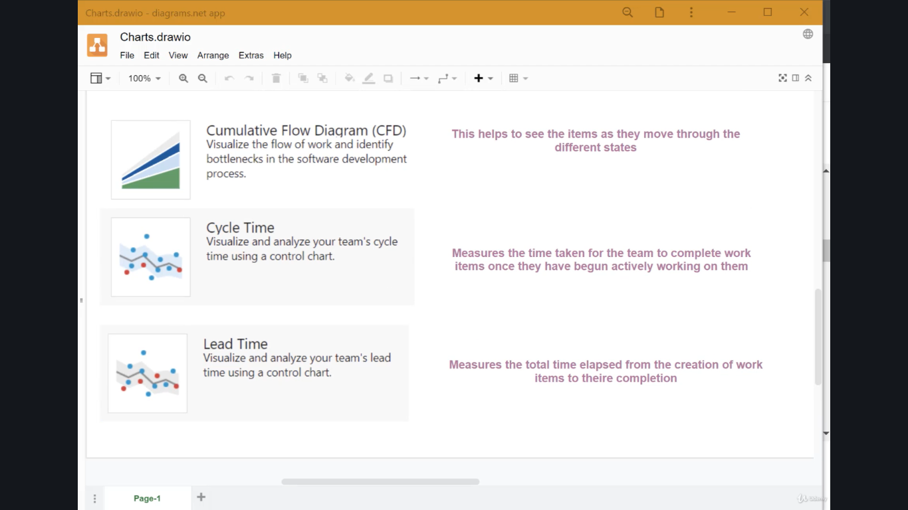

Connect Microsoft teams with Azure DevOps

@azure boards link <https://dev.azure.com/ankurkpuri/SeleniumAutomation>

Host your repository online or centrally-

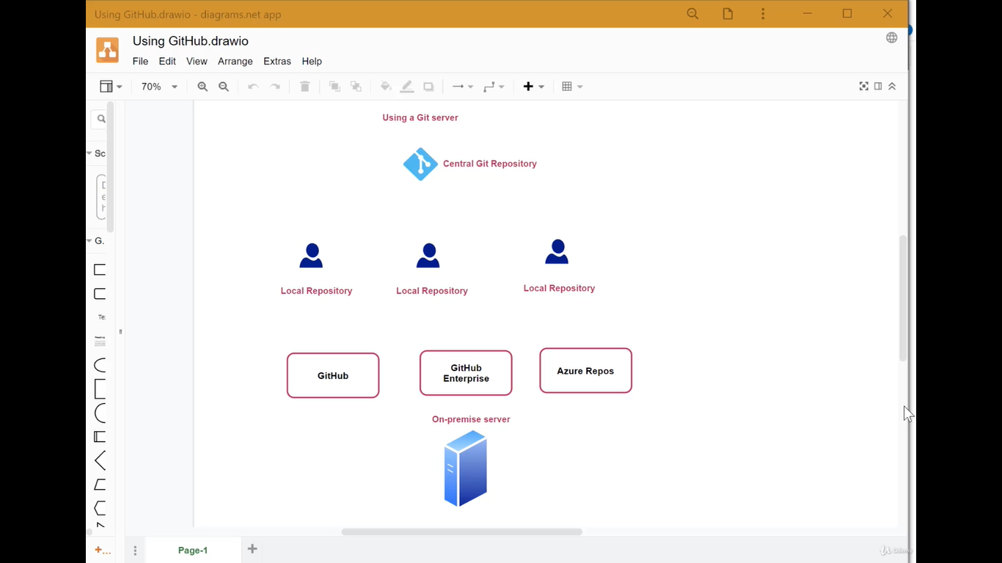

Squash merge-

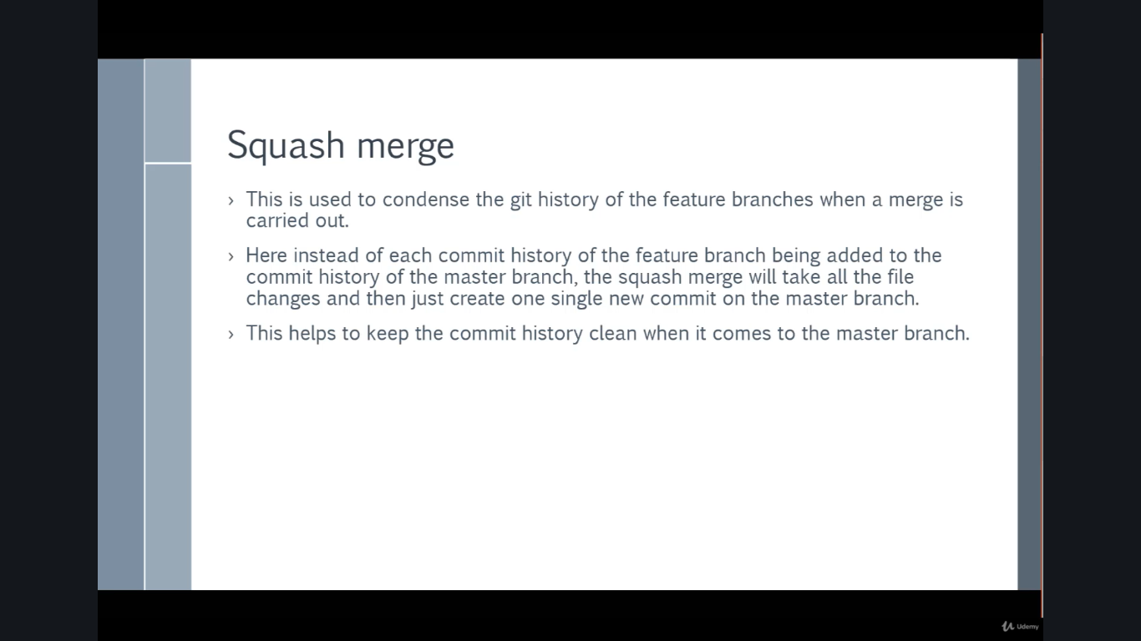

Forking a repository-

